## CSC718 Parallel Programming Midterm

Total: 100 points

Due by Midnight, Oct 16, 2022

(Midterm is a take-home exam. It includes four questions. The last one is a programming assignment. Please submit all your solutions and source code through D2L midterm Dropbox.)

1. (20 points) Binary semaphores only allow the integer to hold the values 0 and 1. However, binary semaphore are easier to implement than general semaphores. Here we demonstrate that a general semaphore can be implemented from a binary semaphore.

A structure of general semaphore is defined as below. It utilizes two binary semaphores. The binary semaphores support two functions.

b_wait(s): decrements s if s>0. If not, the process executing is blocked.

b_signal(s): increments s by 1 (does not change the value if s = 1). After the increment, a process waiting on s resumes its execution.

struct semaphore

{

int value;

int waiting = 0;

b_semaphore queue = 0; // initialized to 0

b_semaphore mutex = 1; // initialized to 1

}

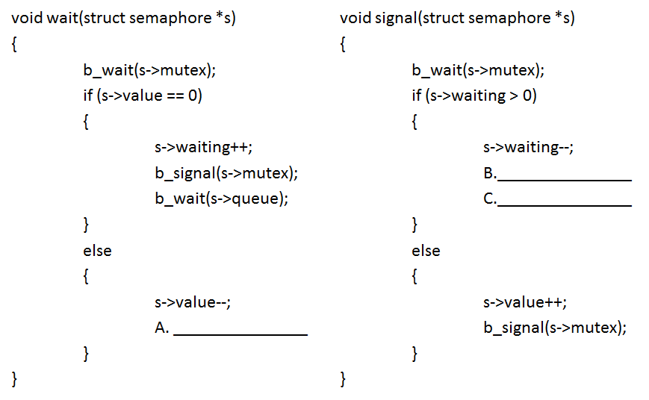

Figure 2

Two semaphore functions, wait(s) and signal(s) are given in Figure 2. However, there are three lines of code are missing. Fill the missing code in A, B, and C.

b_signal(s->mutex);

1. _______________________________
2. _______________________________

b_signal(s->mutex);

b_signal(s->queue);

1. _______________________________
2. (24 points) Assume n pieces of work forming into a one-dimensional array (0 to n-1), p processes, and block allocation (scatters larger blocks among processes) is used. Process rank i starts from 0.
   1. What is the most pieces of work any process has?
 $$\left\lceil \frac{n}{p}\right\rceil$$

  2. What is the least pieces of work any process has? $$\left\lfloor \frac{n}{p}\right\rfloor$$
   3. How many processes have the most pieces of work?
 $$r=n\operatorname{mod}{p}$$

  4. What is the first element controlled by process i?
 $$\left\lfloor \frac{in}{ρ}\right\rfloor$$

  5. What is the last element controlled by process i?
 $$\left\lfloor \frac{(i+1)n}{p}\right\rfloor -1$$

  6. Which process will have the control on element j?
$$\left\lfloor \frac{\left(p\left(j+1\right)-1\right)}{n}\right\rfloor$$

3. (36 points) Programming Assignment: The value of the definite integral

$$\int_{0}^{1}{\frac{4}{1+x^{2}}}dx$$

is π . We can use numerical integration to compute π by approximating the area under the curve. A simple way to do this is called the rectangle rule (Figure 4.7). We divide the interval [0, 1] into *k* subintervals of equal size. We find the height of the curve at the midpoint of each of these subintervals. With these heights we can construct k rectangles. The area of the rectangles approximates the area under the curve. As *k* increases, the accuracy of the estimate also increases.

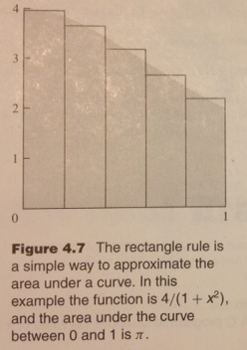

A C program that uses the rectangle rule to approximate π appears in Figure 4.8. The source code, pi.c, can be found in the class website. You can compile and run the program in Linux.

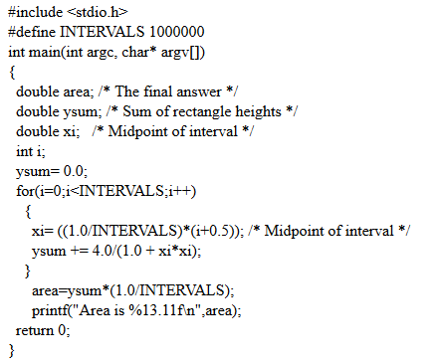

Figure 4.8 A C program to compute the value of π using the rectangle rule.

1. (10 points) Let INTERVALS=1000000, what is pi? Show your calculation result.

$$\int_{0}^{1}{\frac{4}{1+x^{2}}}dx=4\int{\frac{1}{1+x^{2}}dx}=4\tan^{-1}{x}+C$$

* pi is 3.14159265359
* Text

  Description automatically generated

1. (16 points) The program can be converted to a multithread program. A sample program, mth-pi.c, has been provided as below. There are two lines, A and B, which are incomplete. Fill the blanks and complete the program.

ptharg[i].low = _____________A__________________;

ptharg[i].high = ____________ B__________________;

BLOCK_LOW(i, THNUMS, INTERVALS)

1. _______________________________________

BLOCK_HIGH(i, THNUMS, INTERVALS)

1. _______________________________________
2. (10 points) Fill the missing lines in mth-pi.c. Compile and run the program. Let INERVAL=1000000, what is pi? Is it the same value as your calculation result in a).
   * pi is 3.14159265359, it is the same value as my calculation result in a
   * Text

     Description automatically generated

#include <pthread.h>

#include <stdio.h>

#define INTERVALS 1000000

#define THNUMS 3

// thread parametes

struct ThreadParams

{

int id; // id

int low; // start

int high; // end

double ysum; // return partial sum

};

#define BLOCK_LOW(id, p, n) ((id)*(n)/(p))

#define BLOCK_HIGH(id, p, n) (BLOCK_LOW((id)+1,p,n)-1)

#define BLOCK_SIZE(id, p, n) (BLOCK_HIGH(id, p, n)-BLOCK_LOW(id, p, n)+1)

// calculate pi partial sum

void *calcpi(void *arg)

{

double ysum;

double xi;

int i;

struct ThreadParams *pm = (struct ThreadParams*)arg;

ysum = 0.0;

for (i = pm->low; i <= pm->high; i++)

{

xi=((1.0/INTERVALS)*(i+0.5));

ysum=ysum+4.0/(1.0+xi*xi);

}

pm->ysum = ysum;

}

int main(int arc, char* argv[])

{

struct ThreadParams ptharg[THNUMS];

double area;

double ysum;

int i;

pthread_t tid;

void *status;

// create multithreads to calculate partial sum

ysum = 0.0;

for (i = 0; i < THNUMS; i++)

{

ptharg[i].id = i;

ptharg[i].low = _____________A__________________;

ptharg[i].high = ____________ B__________________;

if (pthread_create(&tid, NULL, calcpi, (void*)&ptharg[i]) != 0)

{

perror("error creating child");

return -1;

}

pthread_join(tid, &status);

}

// calculate total area

area = 0;

for (i = 0; i < THNUMS; i++)

{

area = area + ptharg[i].ysum;

}

area = area * (1.0/INTERVALS);

printf("Area is %13.11f\n", area);

return 0;

}

1. (20 points) Programming Assignment: Write a parallel program using MPI that computes the sum 1+2+...+p in the following manner: Each process i assigns the value i+1 to an integer, and then the processes perform a sum reduction of these values. Process 0 should print the result of the reduction. As a way of double checking the result, process 0 should also compute and print the value p(p+1)/2. Please benchmark the running time of the parallel program using the Rushmore cluster as discussed in the class.

|  |  |  |  |  |
| --- | --- | --- | --- | --- |
|  | Np=1 | Np=2 | Np=3 | Np=4 |
| Execution time | 0.000020 | 0.000165 | 0.000111 | 0.000281 |

